Folder requirements in Attachments:

Proposed solution

1) We can add attachment folder in “user admin” master screen under group master.

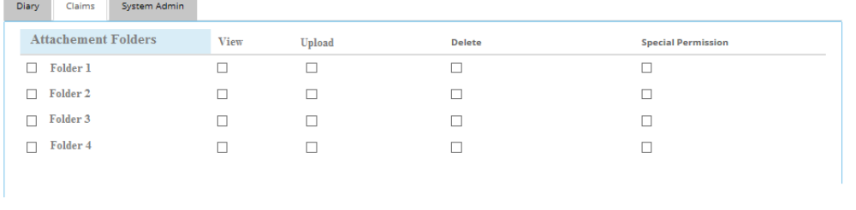

2) View/Upload/Delete permission can be assigned to group level.

for an example:

1) We can assign permissions to a group for Viewing/Deleting/Uploading files to a particular Attachment type which will have a list of Folders.

At the time of Uploading.

1) Attachment screen currently having one drop down list as “attachment type “. In Attachment type we can have 4 folders names.

Viewing

In attachment screen grid, Folders for which user has rights to view can only be seen.

For an example:

1) If User “A” don't have permission for viewing File A which has been uploaded under “Attachment type → folder 1” then he will not able to view that file.

2) Same for uploading, if User A do no have right to save a in folder 2,3,4 then at the time of uploading of files user A will not be able to see the listing of “folder 2,3 and 4“ in attachment type drop down. List.

Uploading

1) At the time of uploading, list of folders for which user has rights to upload can only be seen in the “ Attachment type “ drop down list

Deleting

1) Files in display list can be deleted by user if he/she having delete permission for that folder type files.

